Pupil’s Safeguarding and Child Protection Policy

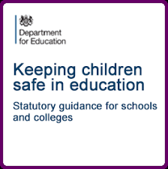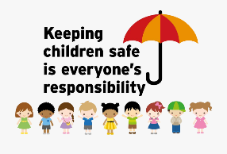

**How will we try to keep you safe?**

We will try and provide a safe environment for you to learn in.

We want to make sure you stay safe at home and at school.

If you need to talk we will listen to you.

We think it is important for you to know where to get help.

**What is safeguarding?**

Everyone at Jubilee L.E.A.D. Academy cares a lot about you!

We want to make sure you stay healthy, safe, and happy.

We work really hard to help you learn, make progress and be happy.

We also teach you how to spot risks, problems and stay safe.

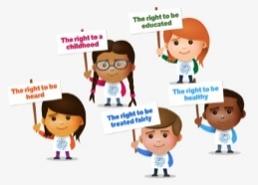

**Tell someone if someone is:**

**☹** Bullying you.

**☹** Saying things to you that upset you or make you feel uncomfortable.

**☹** Touching, hitting or hurting you.

**☹** Taking your things.

**☹** Sending unkind messages on the internet or to your phone.

**Who can you talk to?**

If you are worried about something you can talk to any trusted adult, this could be a member of our staff or any of these adults;

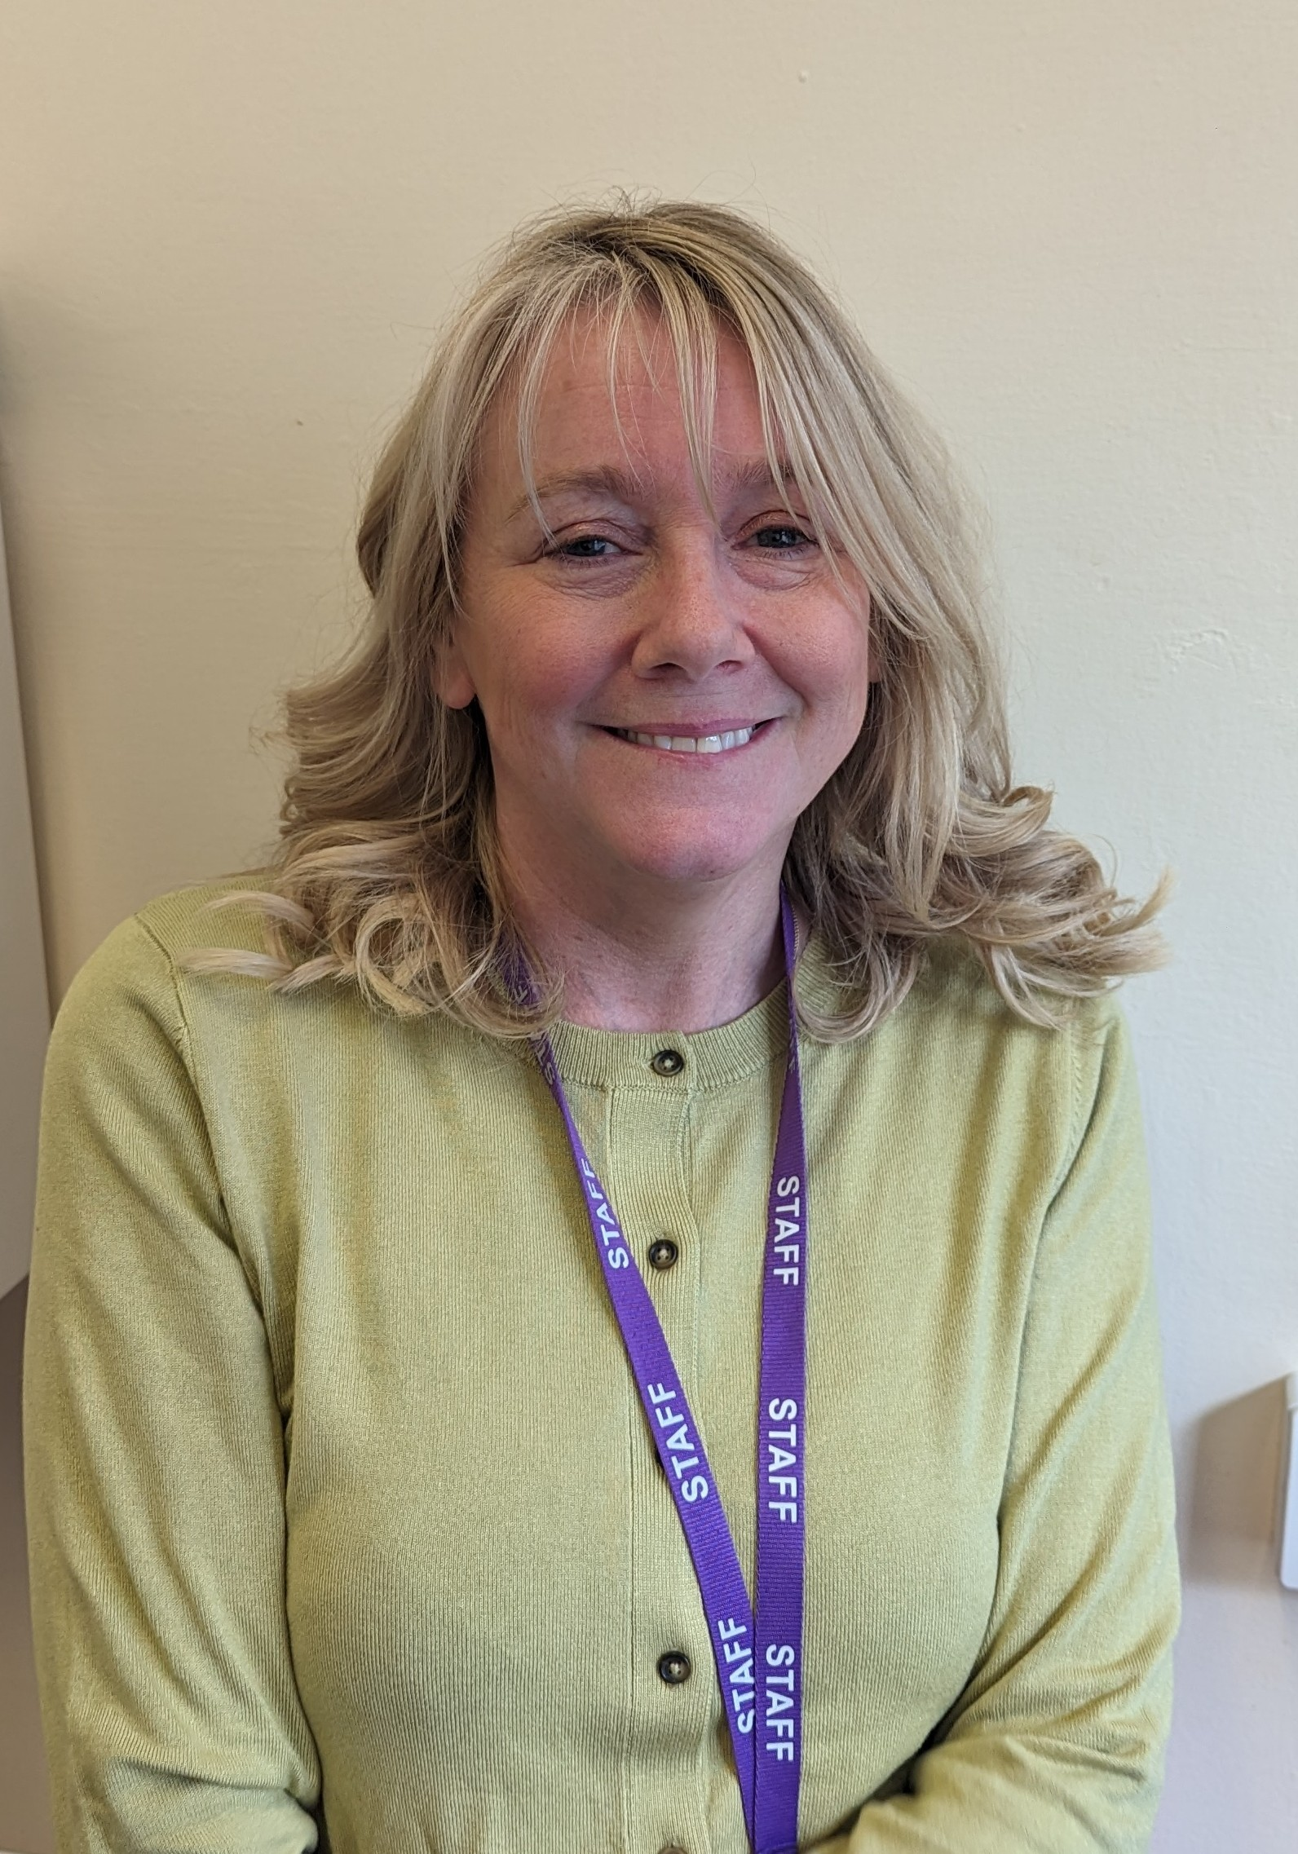

These are our Designated safeguarding leads;

Mrs McIntyre, Mr Brooks, Ms Wheatley, Miss Swan, Mrs O’Connor and Mrs Clarke