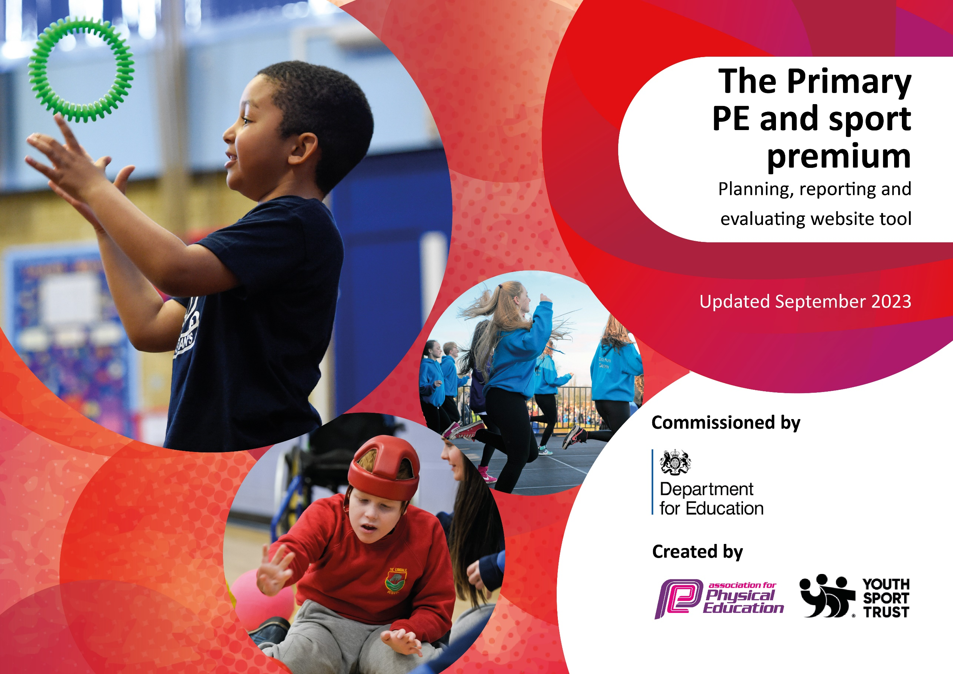

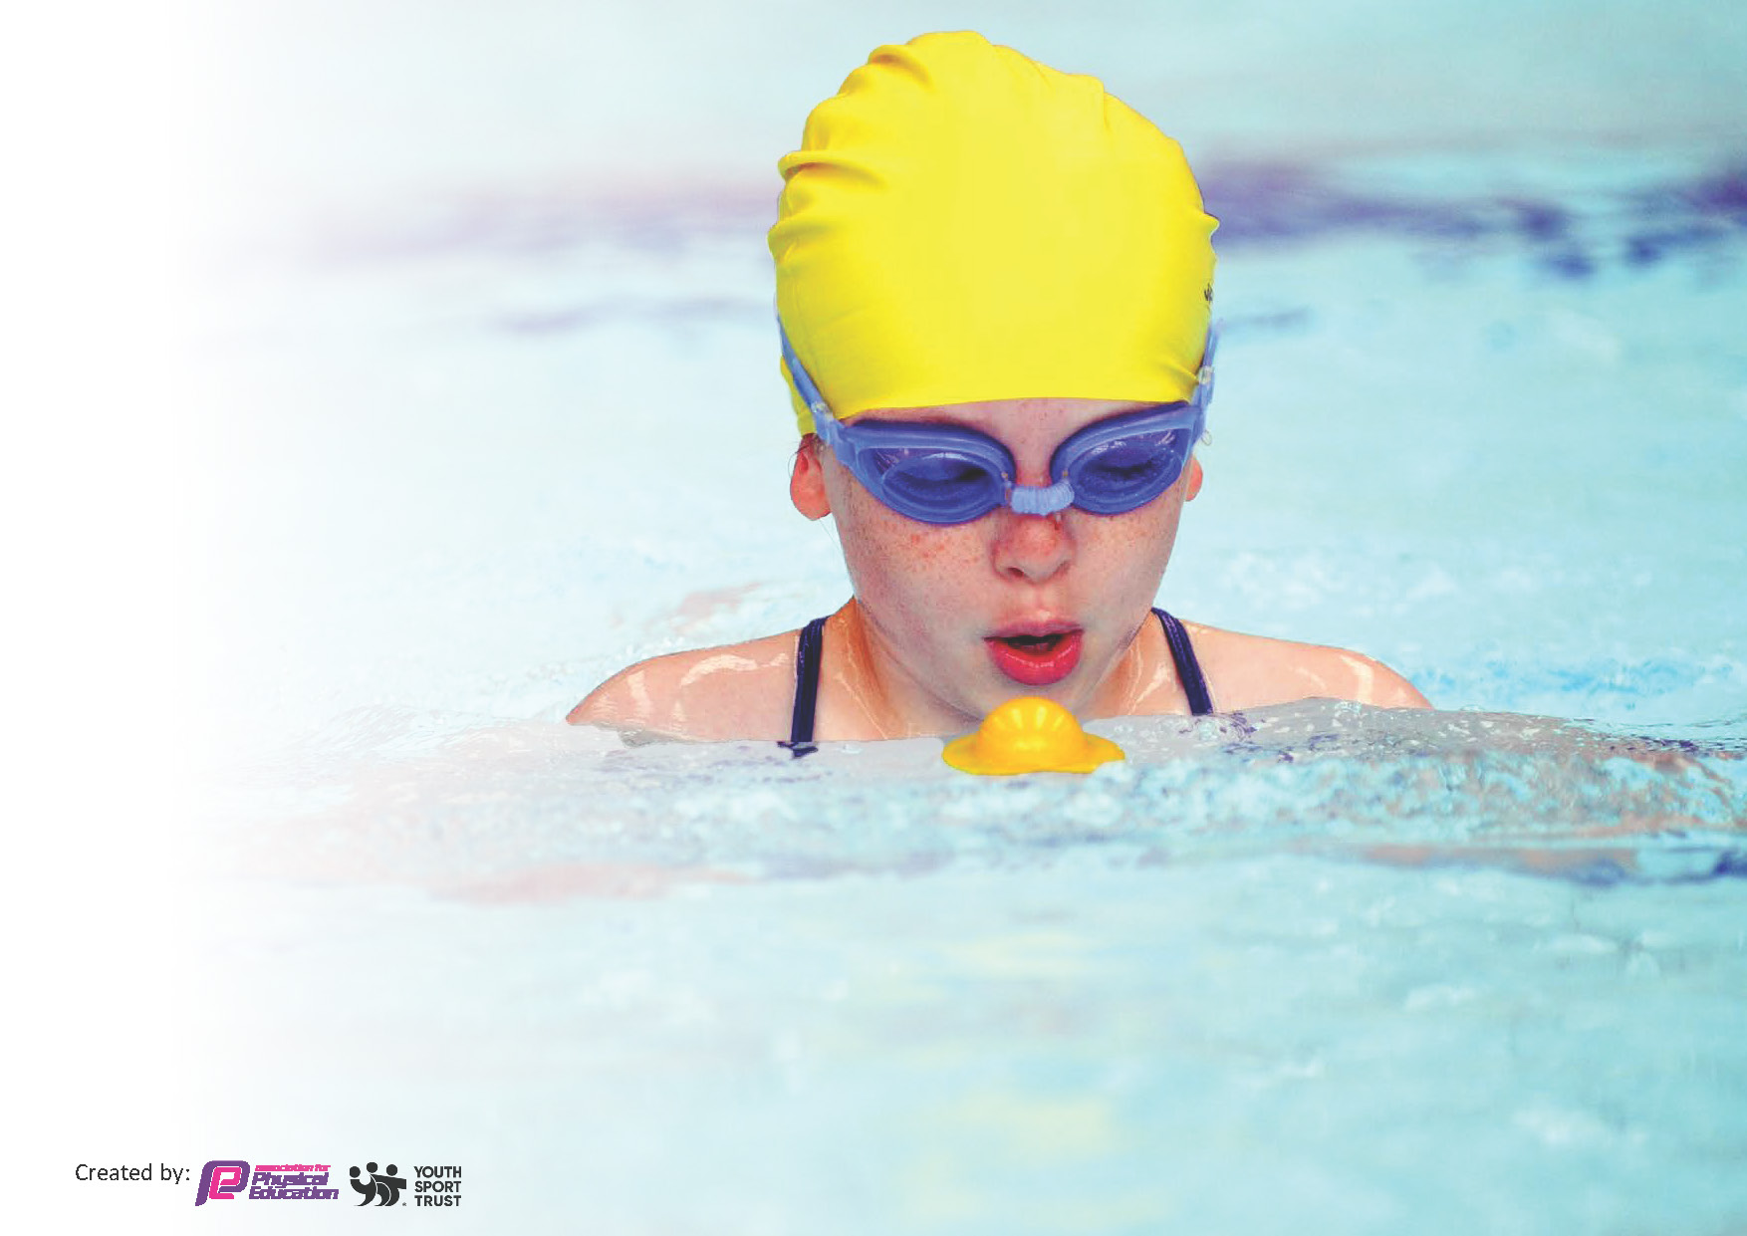
This template can be used for multiple purposes:
by:
- It enables schools to effectively plan their use of the Primary PE and sport premium
- It helps schools to meet the requirements (as set out in guidance) to publish information on their Primary PE and sport premium
- It will be an effective document to support Ofsted inspections enabling schools to evidence progress in Physical Education (PE) and evidence swimming attainment, which forms part of the PE National Curriculum. We would recommend schools consider
the Intent, Implementation and Impact of any spend, as examined within the Education Inspection Framework.

It is important that your grant is used effectively and based on school need.

Schools must use the funding to make additional and sustainable
improvements to the quality of the PE, School Sport and Physical Activity (PESSPA)
they offer. This means that you should use the Primary PE and sport premium to:

- Build capacity and capability within the school to ensure that improvements made now will benefit pupils joining the school in future years
- Develop or add to the PESSPA activities that your school already offers.

The Primary PE and sport premium should not be used to fund capital spend projects; the school’s core budget should fund these. Further detail on capital expenditure can be found in the updated Primary PE and sport premium guidance.

The Primary PE and sport premium guidance, outlines 5 key priorities that funding should be used towards. It is not

necessary that spending has to meet all the key priorities, you should select the priorities that you aim to use any funding towards.

Although completing this template is not a requirement for schools, schools are required to publish details of how they spend this funding. Schools must also outline what the impact this funding has had on pupils’ PE and sport participation and attainment and how any spending will be sustainable in the future. All funding must be spent by 31st July 2024.

The Department for Education has worked closely with the Association for Physical Education (afPE) and the Youth Sport Trust (YST) to develop this template and encourages schools to use it. This template is an effective way of meeting the reporting requirements of the Primary PE and sport premium.
Review of last year’s spend and key achievements (2022/2023)

We recommend you start by reflecting on the impact of current provision and reviewing your previous spend.

Activity/Action | Impact | Comments
New playground equipment purchased and a MUGA created on KS2 playground.  Year 5 Bikeability, Learn to Ride and Scooter-Skills sessions delivered in school  Grant awarded for bikes and scooters  Modeshift Silver Travel Award achieved  Quality of P.E. lessons improved through implementation of REAL P.E.  Teacher C.P.D. increased in the delivery of P.E.  More pupils attended live-sporting events  Sporting successes achieved in competitive inter-school fixtures | More pupils are being physically-active at playtimes and lunchtimes with more pupils also trying more competitive sports such as football and dodgeball.  Increased confidence in biking on local roads, understanding of bike maintenance. Pupils who attended Learn To Ride now have more confidence and skills to ride a bike independently and all of Year 1 received a Scooter-Skills session to improve their confidence and skills.  More pupils will now be able to improve their biking and scooter-skills at school during curriculum and non-curriculum time.  Increase of 62% to 83% of pupils travelling actively to school on a regular basis after the introduction of an 'Active Travel Plan'. Pupils completed Road Safety training, earned Walk to School badges and a range of  Pupils in EYFS, KS1 and years 3-5 benefitted from using elements of REAL P.E. to support their learning in P.E. where particular improvements were noticed in their physical, social and creative skills. Fundamental Movement Skills tests showed that more focus on core skills raised pupils scores in start and end of year skills tests.  Designated P.E. Teacher worked alongside specific Teachers to improve their subject-knowledge and pedagogy, with a particular focus on NQT's and staff new to the school. In addition, the designated P.E. Teacher worked alongside specialists in Gymnastics and Dance to improve his own personal CPD. As such, standards of P.E. lessons have increased and the range of activities delivered to pupils has risen.  Aspirations of pupils has increased as they have been exposed to more live sporting events. Many pupils have now seen first-hand a professional sports player or team in action and this has raised the profile of sport throughout the school through their enjoyment and experiences.  Jubilee achieved a number of awards for sporting successes in inter school-sport. These included silver medals for the Year 6 Indoor-Athletics team and an 18-match unbeaten run for the Year 5/6 Jubilee Jets Basketball Team. | MUGA has ensured competitive games are better contained and safer for lunchtimes and curriculum lessons.  Bikeability has been running successfully for a number of years, but a successful trial of other initiatives means Jubilee would like to continue to offer these to pupils next year.  To be implemented 2023/24 at lunchtimes and during extra-curricular clubs. P.E. Teacher attended training to enable him to deliver sessions.  Pupils completed Road Safety training, earned Walk to School badges and a range of walk, bike and travel activities throughout the year, school focus supported by School Council. First Nottingham City Primary School to achieve silver.  Pupils have really enjoyed using parts of REAL P.E especially in KS1 where the gymnastics and dance units along with the games have proved very popular. The Teachers have appreciated how good the resources are for each year group and KS2 have loved the elements of challenge within the video resources.  EYFS and KS1 Teachers worked with the P.E. Lead to observe and team-teach parts of P.E. Through questionnaires, 100% of Teachers now feel more confident in teaching P.E. and have enjoyed the CPD given.  Due to the demographic of our school-community, it is challenging for many families to afford access to live-sporting events. Pupils loved the experience of attending a sporting arena and watching professionals up-close. It was amongst many pupil highlights during pupil-voice feedback.  Pupils have enjoyed not just participating but now experiencing winning at inter-school fixtures and competitions which has raised the profile and expectations of sport internally and externally.

Key priorities and Planning
This planning template will allow schools to accurately plan their spending.

Action – what are you planning to do | Who does this action impact? | Key indicator to meet | Impacts and how sustainability will be achieved? | Cost linked to the action
Introduce a wider-range of lunchtime sport /activities for pupils.  CPD for all staff in P.E. working alongside the designated P.E. Teacher or external coaches  The increased number of both intra and inter-school competitions has given more pupils the chance to represent the school and play competitively against other schools in a range of sports. | Designated P.E. Teacher, Teaching Assistants and lunchtime staff - as they need to lead the activities. Also Year 5/6 Play-Leaders who are supporting the activities. Furthermore, the pupils in KS1 and KS2 who will benefit from the wider range of lunchtime sports activities.  Designated P.E. Teacher who has delivered CPD and become a more knowledgeable subject-leader, considering the specific needs of individual Teachers.  Teachers who are now more confident in the planning, delivery and assessment of P.E.  External coached who have supported with specific initiatives such as Notts County Coaches delivering Move and Learn (Year 5) as well as Nottingham Cricket Club delivering Chance to Shine (KS1).  Designated P.E. Teacher and Nottingham School Sport Team to organise and attend events. Pupils who have participated who have received a positive experience as a result of participating. | Key indicator 2 -The engagement of all pupils in regular physical activity – the Chief Medical Officer guidelines recommend that all children and young people aged 5 to 18 engage in at least 60 minutes of physical activity per day, of which 30 minutes should be in school.  Key indicator 4: Broader experience of a range of sports and activities offered to all pupils.  Key indicator 1: Increased confidence, knowledge and skills of all staff in teaching PE and sport.  Key indicator 4: Broader experience of a range of sports and activities offered to all pupils.  Key indicator 3: The profile of PESSPA being raised across the school as a tool for whole school improvement.  Key indicator 5: Increased participation in competitive sport. | More pupils meeting their daily physical activity goal, more pupils encouraged to take part in PE and Sport Activities.  More Play-Leaders confident in supporting activities and newly-purchased equipment will ensure it is sustainable. E.g. introduction of bikes, archery sets and large active board-games.  Primary teachers more confident to deliver effective PE supporting pupils to undertake extra activities in school.  P.E. Teacher to continue to team-teach and tailor CPD termly to class-teachers to ensure confidence and subject-knowledge of class teachers continues to remain strong and improve.  Competitively with A, B and C teams in football and basketball which has meant an increase in pupils participating.  Pupils’ enjoyment of sport has improved with pupils keen to represent the school and play competitively against other schools.  The school has sent 25 teams to the local leisure center and local venues to compete in festivals and competitions in sports such as; Multi-skills, athletics, handball, tag-rugby and mass participation events such as a fun-run. | £3,200 costs for additional equipment for both the Key Stage 1 and Key Stage 2 playground.  £3,750 for investment in training for CPD by designated P.E. Teacher and external coaches e.g. gymnastics/dance and to provide subject-leader cover to enable P.E. Teacher to deliver CPD.  £3,500 costs for additional coaches and programmes, along with subject-leader release time to support staff.

Ensure pupils continue to undertake a minimum of 2- hour PE lessons each week.  Continue to ensure that all sporting achievements are recognised and celebrated.  Organise more girls-specific competitive fixtures. As well as the further development of ‘B’ teams to play competitive fixtures against other schools to give more children the experience of competitive matches.  To provide targeted  activities to involve the  least active children  and increase their  physical activity.  To give more pupils’ access to live-sporting events.  To give Year 5 pupils additional swimming ‘booster lessons’ | P.E. Teacher, Teaching Assistants, External Coaches, Pupils.  Staff, pupils and parents.  Pupils, staff, external coaches where necessary, girls and those who currently play less competitive sports.  P.E. Teacher, Teaching Assistants, and  pupils who are identified as possibly being less active than their peers.  P.E. Teacher, pupils, teaching assistants, local sports clubs and parents.  P.E. Teacher, pupils teaching assistants, swim instructors, lifeguards | Key indicator 2: The engagement of all pupils in regular physical activity – Chief Medical Officers guidelines recommend that primary school pupils undertake at least 30 minutes of physical activity a day in school.  Key indicator 4: Broader experience of a range of sports and activities offered to all pupils.  Key indicator 3: The profile of PESSPA being raised across the school as a tool for whole school improvement.  Key indicator 5: Increased participation in competitive sport.  Key indicator 4: Broader experience of a range of sports and activities offered to all pupils.  Key indicator 2: Engagement of all pupils in regular physical activity.  Key indicator 4: Broader experiences of a range of sports and activities offered to all pupils.  Key indicator 3: The profile of PESSPA being raised across the school as a tool for whole school improvement.  Key indicator 2: Engagement of all pupils in regular physical activity. | Pupils have developed more positive attitudes to health and well-being and can now explain why exercise and a balanced diet is good for the body.  Furthermore, pupil concentration, attitudes, self-esteem and behavior has improved within PE lessons as a result of being more active throughout the school day.  In addition, pupils’ stamina has improved meaning they can now maintain higher-levels of physical-activity over a sustained period of time.  Sporting successes (medals, certificates) celebrated within the school’s weekly Celebration Assembly. Sporting achievement celebrated in regular school newsletters and on social-media channels. PE display-board celebrates sporting success and achievements. New end of year celebration events held to celebrate teams’ success.  More girls playing competitive sport and more girls participating in team-based sports meaning the school can enter a wider-range of competitions for girls.  More pupils playing competitive sport will increase participation and aspirations amongst those who are now able to represent the school in inter-school fixtures.  Pupils who usually do not  take part in a lot of physical  activity to become more  active and lead a healthy  life-style with a more positive outlook on their well-being.  Increased confidence and  wellbeing for all children.  Extra-curriculum clubs delivered by P.E. Teacher and Teaching Assistants or specialist coaches.  Improved attitudes to physical activity with the aim that this may lead to further and life-long participation in  sports and sporting activity.  Raise pupil aspirations of playing competitive sport and give them a life-long experience of a live sporting event that will be documented in their ‘Pupil Passport’.  This will increase their cultural capital and allow them to visit a live-sporting event and arena. E.g. Notts County (and NCFC ladies), Nottinghamshire County Cricket, Nottingham Panthers Ice Hockey, Nottingham Rugby and Nottingham Tennis Open.  Increase the number of Year 5 pupils who will achieve their NC swimming objectives to swim proficiently over 25 meters using a range of strokes.  Further increased confidence and understanding of water-safety for pupils.  Additional lessons can target specific pupils as well as groups of pupils. Therefore pupils will leave Jubilee more confident at an important life-skill.  Furthermore, this will help drive the school’s swimming data forwards as we look to improve our swimming data year on year. | £1,500 for investment in Play-leader scheme and training for staff to deliver lunchtime sports’ provision.  £650 renewal of REAL P.E. scheme for use within P.E. lessons.  £500 for resources such as cups, medals and other initiatives to help raise the profile of school-sport and celebrate sporting success.  £750 to cover transport costs to festivals, competitions and fixtures as well as a further £1,250 for teaching and coaching costs to provide extra-curricular clubs targeting girls-only and ‘B-Team’ players.  £600 to cover staffing costs of extra-curricular club and targeted resources.  £750 to cover transport and ticket costs for pupils to attend local sports events.  £2,410 to supplement additional swimming lessons for Year 5 pupils to enable them to achieve the NC expected standards by the end of Year 6.

Key achievements 2023-2024
This template will be completed at the end of the academic year and will showcase the key achievements schools have made with their Primary PE and sport premium spending.

Activity/Action | Impact | Comments
Teachers have been given support in the planning, teaching and delivery of P.E. through CPD with the designated P.E. Teacher  Inter-school competitions have given more pupils the chance to represent the school and play competitively against other schools in a range of sports  The school has competed competitively with A, B and C teams in football and basketball in inter-school fixtures.  P.E. has been used as a driver to support boys’ reading and girls’ participation in football in KS2 through a collaboration with Notts County.  A wider-range of sporting activities have been delivered to pupils. | Teachers are now more confident in the delivery of P.E. lessons and how these are planned, delivered and recorded in both Key Stage 1 and Key Stage 2.  Pupils’ enjoyment of sport has improved with pupils keen to represent the school and play competitively against other schools. The school has sent 25 teams to the local leisure center and local venues to compete in festivals and competitions in sports such as; Multi-skills, athletics, handball, tag-rugby and mass participation events such as a fun-run.  In addition, the school has played competitively in a local football, girls-football and basketball league, completing over 30 fixtures and friendlies.  Over 25 KS2 boys have improved their attitude to reading by reading more at home and in school by working with Notts Countys’ Academy coaches in aspects of reading and football skills. 18 KS2 girls who were not previously interested in football have now trained or played for the girls’ school football team through support from Notts County’s Academy.  Pupils’ have enjoyed new experiences through curriculum and extra-curricular opportunities to try new sports. These include; Tchoukball, Badminton, Archery, biking and Darts. | A newly designed P.E. programme is being trialed to support CPD from September 2024.  Last year, every KS1 and every KS2 pupil represented the school at an inter-school sports event, it is hoped that Jubilee will achieve this again in 2024/25.  Jubilee L.E.A.D Academy achieved 1st placed in Year 5 Sports-hall Athletics at the L.E.A.D sports event and 3rd place in the Year 6 outdoor Athletics competition both held locally at Harvey Hadden Leisure Center.  Due its success, Jubilee L.E.A.D Academy will continue to collaborate with Notts County Academy in 2024/25 with a focus on engaging younger pupils in football (KS1) and working specifically with those identified as less-active.  These new sports will continue in 2024/25 alongside a number of new sporting activities for pupils to try.

Swimming Data
Meeting National Curriculum requirements for swimming and water safety.
Priority should always be given to ensuring that pupils can perform safe self-rescue even if they do not fully meet the first two requirements of the National Curriculum programme of study

Question | Stats: | Further context  Relative to local challenges
What percentage of your current Year 6 cohort can swim competently, confidently and proficiently over a distance of at least 25 metres? | 68% | A very small percentage of our cohort attend swimming lessons outside of school, due to cost. These are expensive to attend in relation to the socio-economic difficulties faced by many within our community. As a result, school swimming lessons are their only opportunity to develop their swimming skills, therefore a significant percentage struggle to achieve the proficiency of competently swimming 25 metres.
What percentage of your current Year 6 cohort can use a range of strokes effectively [for example, front crawl, backstroke, and breaststroke]? | 72% | As stated above, due to the majority of pupils only accessing swimming opportunities within school, a number are unable to use a range of strokes effectively. Many are confident at one-particular stroke such as front crawl or backstroke but less-so with more complex strokes breaststroke and butterfly etc.

What percentage of your current Year 6 cohort are able to perform safe self-rescue in different water-based situations? | 98% | Every child has completed a series of self-rescue lessons delivered by qualified swim-instructors as part of our swimming provision. This figure would have been 100%, however one child was unable to swim during this time due to injury so was unable to participate. All children have also received a water-safety lesson as part of their P.E. curriculum and a whole-school water-safety assembly.
If your schools swimming data is below national expectation, you can choose to use the Primary PE and sport premium to provide additional top-up sessions for those pupils that did not meet National Curriculum  requirements after the completion of core lessons. Have you done this? | Yes | Due to a number of pupils in Year 5 struggling to be on track to meet the swimming expectations of Year 6, this year group has had additional top-up sessions to try and better prepare them to meet their Year 6 end of year distance of 25 metres.
Have you provided CPD to improve the knowledge and confidence of staff to be able to teach swimming and water safety? | Yes | A number of staff have worked alongside qualified swim-instructors to allow them to support SEND pupils within the water. In addition CPD has been given to the P.E. Lead to enable him to deliver classroom sessions and whole-school assemblies on water-safety and first-aid.

Signed off by:

Head Teacher: | Ross Brooks
Subject Leader or the individual responsible for the Primary PE and sport premium: | Neil Kelly – P.E. Teacher
Governor: | Michael Brunner
Date: | 26/7/2024

