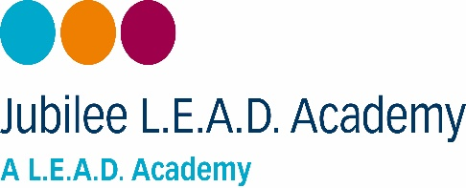

**Year 1 curriculum letter**

**Holly and Oak – Autumn TERM 2**

|  |  |  |
| --- | --- | --- |
|  | **Subject** | **What are we learning this half term?** |
| **Maths** | [Image result for power maths logo](https://www.google.co.uk/url?sa=i&rct=j&q=&esrc=s&source=images&cd=&cad=rja&uact=8&ved=2ahUKEwiX0qGGsZniAhUF1BoKHUZdBKkQjRx6BAgBEAU&url=https://www.pearsonschoolsandfecolleges.co.uk/Primary/Mathematics/AllMathematicsresources/Power-Maths/power-maths-mastery.aspx&psig=AOvVaw0evNnz-NiVD-Vx_CInWH28&ust=1557867023496282) | This term we will be expanding your child’s knowledge of addition by using part whole models, addition within 10, using number bonds and adding using a number line. Pupils will also be developing their mental maths skills through the use of Flash back four, ten frames, Numicon and counting cubes. |
| **English** |  | In English, we will be reading The Dark by Lemony Snicket. Pupils will be immersed in the sensory world of the lead character, Laszlo and how he overcomes his fear of the dark. Pupils will be continuing with their transcription, grammar skills including adjectives and verbs, spelling rules and writing an adventure narrative. |
| **Curriculum** |  | In **Geography**, we will be continuing to develop our locating skills and finding out all about the local area.  In **History**, our knowledge of how our grandparents childhood was different to ours will continue.  In **Science** we be investigating materials and their properties to see which would be the most suitable for a task. |
| **PE** |  | **Labelled** PE kit of **black shorts**, a **plain white T shirt** and **plimsolls** will be required each week on a Friday. These can stay in school for the half term. Ahead of PE days, **jewellery must be removed**, and **long hair should be tied back** in a ponytail. |

** Monday 4th November 2024**

Dear Parents/Carers,

A warm welcome back to Year 1 from Mr. Ganley, Miss Brown, and Mrs. Unwin who are eager to continue on our learning journey.

This term your child will continue to develop their phonics knowledge, expand their use of grammar, develop Mathematical skills and take part in exciting curriculum lessons including; Science, Geography, History, P.S.H.E, Computing, R.E, Art, Design and Technology and Music.

Year 1 will have P.E on a Friday, please ensure your child has a plain white T-shirt and black shorts and appropriate footwear.

Please find attached our curriculum overview and **how you can support your child at home**.

This includes (but is not limited to):

* Completing **weekly homework** (given out on a **Friday**) for the **following Wednesday**. If homework is not completed, children will be asked to complete it during their break time.
* **Reading with your child at least four times a week at home**. Your children will be rewarded with book tokens each time they read at home. They can save these up throughout the year and buy books from the book shop as a reward for their hard work. When you read with your child at home, please write in your child’s diary (including the date read) and send diaries to school each day as reading will be monitored daily.
* Please encourage your child to **play on SumDog** to help develop their maths fluency.

If you have any queries or concerns, please contact your child’s class teacher. Thank you for your continued support with your child’s learning.

Best wishes,

**Miss Brown (Holly), Mr. Ganley (Oak), Mrs. Unwin (Year 1 Teaching Assistant)**