**YEAR 6 CURRICULUM – Autumn 2**

|  |  |  |
| --- | --- | --- |
|  | **Subject** | **What are we learning this term?** |
| **Power Maths** | [Image result for power maths logo](https://www.google.co.uk/url?sa=i&rct=j&q=&esrc=s&source=images&cd=&cad=rja&uact=8&ved=2ahUKEwiX0qGGsZniAhUF1BoKHUZdBKkQjRx6BAgBEAU&url=https://www.pearsonschoolsandfecolleges.co.uk/Primary/Mathematics/AllMathematicsresources/Power-Maths/power-maths-mastery.aspx&psig=AOvVaw0evNnz-NiVD-Vx_CInWH28&ust=1557867023496282) | This term in Year 6 we will be pushing harder on our arithmetic skills in preparation for SAT’s. Although Power Math’s will still be used, the children will be doing a lot of work in their strengthening and deepening books, covering a range of topics. The children are doing amazing so far. Can we ask all parents to ensure children are completing math work that is sent home to allow them to get in good habits or repeating methods. Any additional practice outside of school would be highly encouraged also. |
| **Literacy** |  | This half term in literacy we will be focussing on the novel ‘After The War’ by Tom Palmer. This book links fantastically to our curriculum topic of WW2 and the holocaust. This is a historical fiction about 300 children who were evacuated from Auschwitz, having survived the horrors of the Nazi concentration camps, to find peace and safety in the Lake District. During this topic children will explore different genres of writing such as a first person diary entry and descriptive narrative. |
| **Curriculum** | The Cenotaph | English Heritage | Our curriculum focus this term is all about both WW1 and WW2 and how they affected people in our local area. The children are excited to learn all about the key events of the world wars and are already asking inciteful questions. If you have any family members who can help provide personal experiences with this topic please feel free to contact school, as this will benefit the children in our class discussions and learning. |
| **PE** |  | This term the children in will need their PE kits every Friday.  Within this unit of PE children will be working with a dance teacher.  Please note – Children **MUST NOT** wear earrings to school on this day or they will not be allowed in the pool. |

**Year 6 curriculum focus – Autumn term 2**

Dear all,

I hope the children and yourselves have a well-deserved rest and children come back refreshed and ready for Autumn 2. Important dates have already been sent out to you, so keep an eye out for all our key dates surrounding out school festivities. Although this term is very exciting, the children will still need to be focused and driven to completing daily tasks and learning.

Uniform:

The children look very smart and professional in their blazers and ties. Going forward it is absolutely vital that the children take care of their uniforms, which includes looking after their ties and blazers, resulting in them entering the school gates looking consistently smart throughout the year. Please put your child’s name in their uniform as this will help us to reunite missing items with the correct child.

Reading:

There is a huge push this year in year 6 to ensure the standard of reading is at the highest possible level. Your children must read 4 times a week at home and ensure this is logged in their reading diaries. Please may parents sign this reading diary before sending their child to school, as this will help us to know who has completed their reading. Reading is very important to everything we do at Jubilee, and we want the children to become lifelong passionate readers.

If you have any questions or wish to speak to any member of the year 6 team, please see us at the end of the day or contact the office to get in touch.

Kind regards,

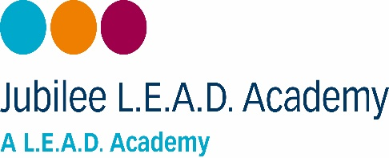Ms Matumbike & Mrs McGuire